A Web-Based Football Talent Identification and Exposure System in Kenya

183983
190757

An Information System Project Documentation submitted in Partial Fulfilment of the
requirements of Bachelor of Business Information Technology

School of Computing and Engineering Sciences

Strathmore University
Nairobi, Kenya

May 2026

DECLARATION
We declare that this work has not been previously submitted and approved for the award of a Bachelor in Business Information and Technology from this or any other University. To the best of our knowledge and belief, the proposal contains no material previously published or written by another person except where a reference is made in the proposal itself.

Student’s signature:

…………………………………. [Signature]

………………………………….. [Signature
………………………………….………….. [Date]

Abstract
This study looks at young talented footballers especially in Africa and particularly Kenya who find it difficult to get opportunities to play football professionally. This issue affects young football players in grassroots and local communities, limiting their potential, leading to wastage of talent and diminishing their passion for the sport. This leads to underdevelopment in the football sector locally and even potential representation on the global level. The current systems are not suitable for the scouting of young players being mostly informal, lacking data-driven and a centralized platform for scouts to identify potential talents. In Kenya specifically, initiatives like the CBC curriculum which integrates sports into education and FKF (Football Kenya Federation) which conducts nationwide scouting drives have attempted to bring solutions. Despite these efforts been made, the systems are still mostly traditional and informal indicating unstructured and unprofessional sports management systems. Therefore, the project proposes to create a web-based talent identification system that seeks to improve visibility, opportunities and interaction between players and scouts. The system aims to provide structured player profiling, video posting and skill display, opportunity posting for scouts like tournaments and trials and communication opportunities. To achieve that the system uses an Object-Oriented Analysis and Design approach by Agile methodology to enhance modularity and development targets by representing real-world entities like players and scouts as objects. The proposed system utilizes various tools in design and development such as IDE (Visual studio), Django’s architecture, HTML, XAMPP and Draw.io.

Table of Contents
DECLARATION ii
Abstract iii
Table of Contents iv
List of figures vi
List of abbreviations vii
Chapter 1: Introduction 1
1.1 Background 1
1.2 Problem Statement 2
1.3 Aim or General Objectives 2
1.4 Specific Objectives 3
1.5 Justification 3
1.6 Scope 4
1.7 Limitations & Delimitations 4
Chapter 2: Literature review 6
2.1 Introduction 6
2.2 Assessment of Current Football Talent Identification Systems in Kenya 6
2.3 Challenges and gaps 7
2.4 Review of Existing Systems 8
2.4.1 HUDL 8
2.4.2 Football academies 9
2.4.3 Competency-Based Curriculum (CBC) in Sports Development 9
Chapter 3: Methodology 12
3.1 Introduction 12
3.2 Research approach 12
3.3 Methodology 12
3.3.1 Product backlog 13
3.3.2 Sprint planning and backlog 14
3.3.3 Sprint (Development phase) 14
3.3.4 Finished work (Testing) 15
3.4 Deliverables 15
Chapter 4: System Analysis and Design 16
4.1 Introduction 16
4.2 System Requirements 16
4.2.1 Functional Requirements 16
4.2.2 Non-Functional Requirements 17
4.3 Analysis and Design Diagrams 18
4.3.1 Use case Diagram 19
4.3.2 Class Diagram 20
4.3.3 Sequence Diagram 21
4.3.4 ERD Diagram 22
4.3.5 Database Schema 23
4.3.6 Wireframes 24
References 25

List of figures
Figure 2. 1:Hudl dashboard represents digital scouting system (David Graff, 2026) 9
Figure 2.2: Conceptual diagram for the football talent identification and exposure system 11
Figure 3.1: Illustration of Scrum model steps (geeksforgeeks.org, 2023). 13

Figure 4. 1:Use Case Diagram 19
Figure 4. 2:Class Diagram 20
Figure 4. 3:Sequence Diagram 21
Figure 4. 4: ERD 22
Figure 4. 5:Database Schema 22
Figure 4. 6:Wireframes 23

List of abbreviations
CBC ------ Competency-based Curriculum
CSRF----- Cross-Site Request Forgery
CSS ------ Cascading Style Sheets
FKF ----- Football Kenya Federation
FIFA ------ Federation Internationale de Football Association
HTML ------ Hypertext Markup Language
IDE ------ Integrated Development Environment
OOAD ----- Object-Oriented Analysis and Design
SSAD ----- Structured Systems Analysis and Design
UML ---- Unified Modelling Language
XAMPP ---- Cross-Platform, Apache, MySQL, PHP and Perl
XSS ----- Cross-Site Scripting
ORM ----- Django's Object Relational Mapper

Chapter 1: Introduction

Background
Talent identification and exposure remain a challenge in developing regions such as Kenya and across Africa. Particularly in football, many talented players lack access to opportunities that would allow them to display their abilities. This is a major concern because undiscovered talent limits personal growth and football development as a sport. Furthermore, the problem persists as existing scouting solutions and systems fail to reach many players, especially those in developing areas, thus leaving them unidentified and unable to progress to professional levels. This problem is caused by restricted access to key opportunities, such as trials and competitive grounds, which are essential for developing and exposing football talent. Sport development researchers acknowledge that football talent development at grassroot level is vital, but inadequate scouting systems hinder effective talent identification (Alemmebrat, 2022) while other scholars argue that professional football academies are structured for identifying and developing talent (Paul R. Ford, 2023).
This problem primarily affects young talented players, particularly those in developing communities, as well as football clubs and the broader sports industry. These individuals are affected by limited access to opportunities that allow them to showcase and develop their abilities. The existing methodologies and systems are limited in reach and often rely on informal methods. If the problem is not addressed, it leads to wasted talent and reduced productivity among the youth. Moreover, this increases the likelihood of the young people engaging in negative social activities. Research shows that the talent identification systems are weakly-structured leading to high levels of underdeveloped talents (Sérgio Ribeiro, 2025).
However, football academies and physical scouting have played a good role in supporting young talented players. The establishment of these academies has attracted many individuals to by offering scholarships and development programs. This has provided opportunities and stepping stones for them to pursue their football dreams. Despite this, access to such institutions remains narrow and constrained for young people in developing areas. This has created a gap in equal access to competitive opportunities regardless of the geographical location. Recent developments have introduced digital tools and machine learning techniques to support scouting processes (Rohit, 2025). On the other hand, these advancements have not yet reached the grassroots level therefore not widely accessible to many aspiring players.
The project aims to improve the current situation by developing a centralized and accessible web-based platform that connects the young football players to ground-breaking talent exposure opportunities. Unlike other existing systems, such as football academies, it integrates player profiles with information on trials and tournaments in one place. The system also improves visibility by allowing scouts and organizations to post their opportunities based on any criteria, such as age, location and football playing position. This approach promotes equal access to opportunities for aspiring players. Research supports that there is a need for a systems-based approach to identifying talents in youth football (Rahim, 2025).

Problem Statement
The problem is that at the grassroots level, in developing regions such as Kenya, youth talent identification and exposure are often overlooked. This is evident in the low representation of African countries in global competitions such as FIFA World cup, reflecting challenges of identifying and developing talent early. These young talented players lack access to growing opportunities thus remain undiscovered. Research supports this concern, a study by (Mwangi, 2023) states that although investment in sports increased from Kshs. 11.60 to Kshs. 38.68, the resources remain inadequate and poorly managed, indicating persistent inefficiencies in talent development.
This is a major problem because it leads to wastage of talent and leads to degradation of football both locally and internationally. Due to the lack of established systems for scouting and exposure, players struggle to progress from grassroots to elite levels, resulting in missed opportunities for individuals and reduced competitiveness for national teams. Recent initiatives by (FKF calls for data-driven scouting as nationwide scouting reforms get underway, 2026), emphasize the much-needed enhancement for data-driven scouting systems to bridge the gap between grassroots football and elite competition, further confirming that the absence of structured talent identification frameworks is a critical challenge (Streamline, 2025) and reports that FIFA has invested approximately Ksh 1.7 billion in Kenyan football development between 2016 and 2022 through its Forward Development Programme.

1.3 Aim or General Objectives
To develop a web-based football talent identification and exposure system where talented football players can cross paths with scouts from various clubs in Kenya to receive opportunities to play football professionally.

1.4 Specific Objectives
- To assess the current football identification systems in place and how they work regarding the success of players being scouted, specifically in Kenya.
- To identify the limitations of current football identification processes including lack of a centralized platform for players to interact with scouts, display their talent profiles and get information about existing opportunities.
(iii) To design a web-based platform for players to interact digitally with football talent identifiers for professional institutions and clubs.
(iv) To develop a system with features that allows players to create profiles and upload their information, player search functionalities and even soccer tournament and trials awareness.
(v) To test the functionalities and performance of the system according to the proposed functional and non-functional requirements.

1.5 Justification
The need for this project is to bring opportunities and more exposure to young footballers in Kenya to the international level. The current mechanisms for scouting and identifying players especially in undeveloped areas are manual, decentralised and inefficient, leading to lack of visibility of potential stars. Little initiative and investment are being taken to develop the football scouting system in this sport. A study by Mwangi shows that most schools are under-resourced in terms of sports facilities and that the available resources are poorly maintained, limiting effective participation and development of sporting talent (Mwangi, 2023). This limits equal opportunities to everyone in the country to be seen and given a chance to enhance their talent and for scouts and clubs to make informed choices.
A digital solution would not only save time but also enhance the process of scouting young players and give awareness to upcoming trials to increase their chance of success. Research shows modern approaches emphasize the need for multidisciplinary and data-driven systems to improve the reliability and efficiency of talent identification processes, as traditional methods are mostly subjective and inconsistent (Sam Barraclough, 2022). This can create a structured, centralized place for talent identification using information provided by players like playing positions, posting videos and history of playing. This information can help recruiters and scouts to select specific players by the attributes they are interested in pursuing for their clubs. This can also benefit the country by enabling representation globally when these players are scouted internationally, not only in status but also in growth as a nation. This project will also support government efforts due to initiatives like competency-based curriculum which has promoted early talent identification by playing sports, a core component in early education of children.

1.6 Scope
The proposed system aims at providing identification and development of young football prospects in Kenya by providing a centralized system for player profiling and scouting. The system will cover player profiles which will have information regarding their football talent like position and playing style and allow photo and video uploads. The scouts or coaches can search and view player profiles and contact them using player information. There will also be a page for announcements about trials and tournaments posted by scouts and coaches which scouts are likely to be present. The stakeholders of the system including the players, scouts, managers, football institutions majorly who can input data and other indirect stakeholders like sports regulators can access the system, and view information. The system will accommodate processes like player registration, profile creation, tournament and trials listing and scouts search process.
The project will incorporate usage of tools during the software development life cycle like a database for storing player information, Microsoft tools like Visio for design and an IDE for development of software. It will use simulated data and information to facilitate functionality and testing which will be limited (not in the real world). Testing and examination will be done based on defined functional and non-functional requirements. The project, however, will not cover enhanced features like biometrics, live streaming/ updates, integration to other sports databases thus it will be independent. It will not also necessitate regulatory approval or enforcement since it’s an academic project. The system will also not disregard or demean any current mechanisms for football player identification. Functionalities like contract signing, payment mechanisms, will not be part of the system since the focus is on contact of players to recruiters

1.7 Limitations & Delimitations
The process of development of this proposed software during the software development life cycle may bring challenges including but not limited to the following observations. Limitations in simulating real life dependable and realistic on ground data for testing. Digital resistance in implementation of the solution as processes may still be manual and based on ground. Technical limitations relating to resources and tools accessibility, availability, and usage. To mitigate these challenges, the project will use an iterative development approach where frequent testing of developed functionality will be tested before progressing to further advancement. Addition of data validation processes to make data dependable and relevant to the sport. Using software development life cycle phase to identify and address issues early in development improving system functionality.

Chapter 2: Literature review

2.1 Introduction
This chapter discusses the research, efforts, gaps and existing solutions that have been made to progress the identification and development of young football players. It describes the sport (football), how it has an impact on young talented players and explains the business processes of the sport. The chapter also describes possible solutions and innovations to bridge this gap for young players. It shows the impact of this sport to the young potential talents and how if the challenges are not addressed leads to consequences. This chapter also indicates the challenges and possible gaps that can be identified backed by various literature and illustrates existing solutions that have been done. Finally, it demonstrates a conceptual diagram which shows an innovative angle to tackle the gaps and enhance existing solutions.

2.2 Assessment of Current Football Talent Identification Systems in Kenya
This is about the current sports sector and in specific football also known as soccer, which is one of the most popular sports around the world. Many young players around the world play this sport as a hobby while others with a focus of playing professionally.
The sports business has several processes like football talent identification which is a major factor and development of talent. Other processes are competition and exposure, data management of players in terms of player information and players progression from identification to career level. The focus being on football talent identification, it is a crucial part of football since that is where potential football stars are discovered. Although soccer is a sport which can be played professionally, research shows that young talented players especially in Africa find it difficult to get opportunities due to lack of systems and infrastructure (Waffo, 2025).
According to the (FIFA Talent Development Scheme, 2022), talent development is a structured pathway that ensures players are identified early and supported through training, competition, and progression stages. Therefore, the focus is to potentially strengthen the scouting and identification systems of young football players especially in Africa. FIFA identified and emphasized some principles for fairness and guidance in the football sports sector like equal opportunity rule, structured talent identification, transparency and use of data and technology (FIFA, FIFA Talent Development Guidelines, 2023) . Lack of a structured, centralized and data driven system is causing deficiency in football talent scouting. Football Kenya Federation (FKF) admits to this issue in a statement by Mohammed “Kenya has world-class talent… what has been missing are proper structures and long-term development pathways” (Mohamed, 2025).
What is expected is better infrastructure and systems in terms of opportunities for young players nationally to develop their talents. On the ground the truth is that these young players play for their local teams and street football hoping that an opportunity can arise from somewhere. This aligns with research indicating that youth in Kenya, particularly in informal settings, engage primarily in community-based and informal activities due to limited structured opportunities for development (Del Fava, 2021).

2.3 Challenges and gaps
The major factor in this field is that Kenya and Africa do not lack footballing talent but there are limited systems structured to expose these young talented players to further progress. A study further shows that Africa, despite the potential, lacks structured and equitable scouting systems (Emmanuel, 2026). This problem is still present due to lack of structured systems especially in Kenya where reliance is on school competitions and informal trials. There is a lack of data driven solutions that help scouts and recruiters to be informed in selecting talents. African talent identification is described as “a game of chance” due to lack of structured data and visibility (John et al., 2023) (Ribeiro et al., 2025).Research shows that limited data and research has been done especially in Africa regarding this problem, indicating a lack of localized academic research (Ribeiro et al.,2025).This lack of research and initiative further illustrates why the state of conditions is remaining the same. Research notes that limited long-term data linking early indicators to long term success (Paul,2024).
Late discovery of players and talent loss due to biasness of scouting where preference is in developed areas and certain playing styles. (McCalman, 2022)highlights that there is no standardized method for assessing football skills, which shows that it is by luck that some of these players are scouted, maybe due to their geographical access to scouts. This continues to show the need for a centralized and data driven platform to display the talent of young players. The consequences of these problems are wastage of potential talent and little representation of Africa in top football leagues like premier league. A research dataset shows that African players make up only about 7% of Premier League players (2021/22 season) showing that African influence in professional football is low (Armstrong, 2022). This is primarily due to limited scouting and identification initiatives in Africa.
There have been efforts through Football Kenya Federation and the government which have promoted initiatives like nationwide Under 14 and 15 scouting programs by FKF (Kitamba, 2025). The government also made efforts using the Competency Based Curriculum by playing sports as an official subject thus increasing talent development and identification in young students. Research shows that CBC promotes early talent identification through grassroots development structures (Nashipae, 2022). These initiatives have increased the chances of students and young footballers to discover their talent earlier and progress using available opportunities. Although this has helped it still has not made significant progress in the national scouting process as it is still more informal and unstructured. There remains an opportunity for a centralized, structured and data driven approach to solve this problem.

2.4 Review of Existing Systems

2.4.1 HUDL
Hudl is a digital platform designed to support athlete performance analysis through video-based tools. It enables coaches to upload match footage and share highlights with scouts and recruiters. The platform relies on video analytics, cloud-based storage and data management technologies to support performance review and talent identification in the sports environment. Overall, Hudl has established itself as a global platform in modern football and other sports. Research shows that Artificial Intelligence techniques such as image processing and machine learning are widely used to analyse players’ performance and movements, supporting talent exposure in sports contexts (Fabian Hammess, 2022). These technologies are implemented on platforms such as Hudl.
However, it is mainly accessible to organized teams, institutions and structured sports programs, limiting its reach to grassroots and independent players who have limited access to such environments and resources. As a result, this reveals a gap in direct talent exposure, which the proposed system seeks to improve by providing a centralized platform for player scouting and visibility.

Figure 2. 1:Hudl dashboard represents digital scouting system (David Graff, 2026)

2.4.2 Football academies
Football academies are systems designed to identify, train and nurture young players into professional athletes. These systems provide training environments where selected players receive mentorship, coaching and competitive match experience. Academies rely on traditional talent identification techniques such as physical scouting, trial-based selection processes and coach-based assessment of player performance. Research indicates that football academies play a significant role in the modern football ecosystem by contributing to long-term player development of pure young talents into professional grounds (Dimitris Kothroulas, 2025).
Nevertheless, football academies depend heavily on physical trials and local visibility, which limits their scouting reach. Thus, only a small number of selected players are admitted into the system while many talented players remain undiscovered. This creates a gap in broad player visibility and inclusive talent exposure within the football development structure.

2.4.3 Competency-Based Curriculum (CBC) in Sports Development
The Kenya Institute of Curriculum Development introduced the Competency-Based Curriculum (CBC) to support holistic learner development, including the identification and nurturing of talents in sports. The system addresses the challenge of early-stage talent identification by integrating sports into major school activities, where learners participate and are continuously assessed in co-curricular programs. Research adds that CBC is an effective bottom-up approach to sports development, particularly at the grassroots level (Nashipae T. , 2022). The curriculum utilizes and relies on structured participation, continuous teacher observation, assessment and performance reviews as key techniques in identifying and developing learners’ abilities over time.
On the other hand, Scholars argue that CBC faces several challenges such as inadequate teacher training, limited funding and implementation inconsistencies across schools, especially in Kenya (John Muchira, 2023). As a result, many young talented players lack accessibility beyond local environments, creating a gap in wide progression pathways and continuous talent visibility within the football ecosystem.
2.5 Conceptual Diagram
The proposed system works by how each actor (player, coach/scout & admin) interacts with the system through clear input and processing flows. Players can input their data by registering, creating profiles, uploading videos and applying for opportunities while coaches/scouts can register, view player profiles and post opportunities. Admin can manage users and monitor the system. Once data is submitted, the system processes it in particular modules as shown below. All processed data and updates are stored in a centralized database in the back end ensuring security and accessibility to the saved data. From the storage, the system generates outputs such as reports and specific data to the different users using the system. By providing a centralized platform where different users’ roles and ensuring a smooth flow of processes enhances visibility, transparency in football talent identification.
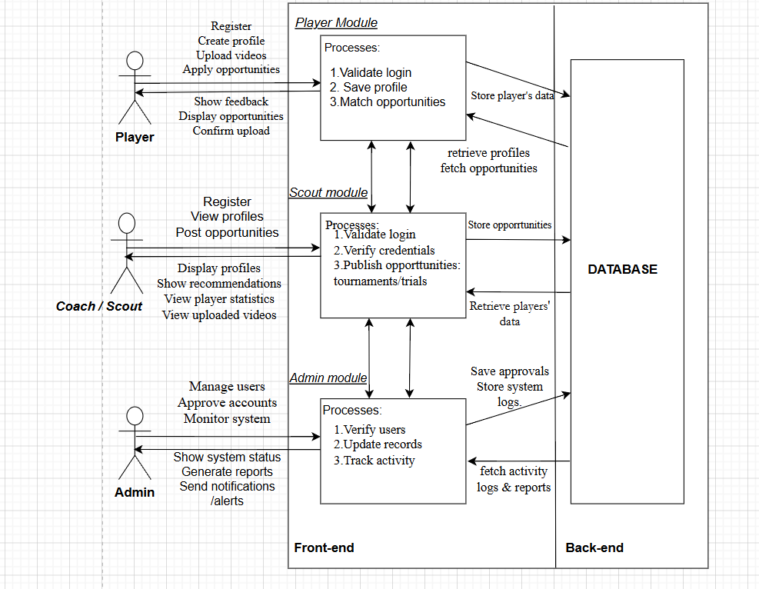
Figure 2.2: Conceptual diagram for the football talent identification and exposure system

Chapter 3: Methodology

3.1 Introduction
This chapter discusses the methodology and development approach that will be used in the development of the football identification system. It explains the selection of Object-Oriented Analysis Design (OOAD) over Structured System Analysis and Design (SSAD). It further discusses the adoption of Scrum model, under Agile methodology to support iterative and flexible system development. The chapter also highlights the tools and techniques that will be used in design diagrams and technologies applied in system development. Finally, it presents the expected deliverables, including system representations, documentations and reporting mechanisms that supports decision-making in the football talent identification and exposure.

3.2 Research approach
There are two primary methodologies for software development OOAD and SSAD. SSAD, which is Structured systems analysis and design is a methodology which uses structured, step-by-step development for systems that have processes and procedures. It also separates data and processes by representing them in diagrams like Data flow diagrams. OOAD which is Object oriented analysis and design is an object-oriented methodology that uses real world entities or objects and classes that can perform certain functions. Since our project uses real world entities like players, scouts and coaches an object-oriented approach will be more suitable for the system. The use of UML in system software design, as demonstrated by (Zhang, 2022), shows the application of object-oriented analysis and design (OOAD) principles in developing object oriented, modular and scalable systems.

3.3 Methodology
The proposed system will utilize Agile methodology due to its iterative and flexible nature. In the proposed system, features such as player profile management, opportunity posting and scouting functionalities will be developed progressively in manageable modules. These modules rely on continuous improvement while incorporating feedback from intended users, which is supported by the adaptive methodology. This approach ensures that the developed solution effectively addresses the challenges faced in football talent identification and exposure. Studies confirm that Agile methodology improves flexibility and responds effectively to changing requirements such as the football talent identification system (Prisca Amajuoyi, 2024)
The Scrum model, an implementation of Agile methodology, will specifically be used in the development of the proposed football talent identification system. Scrum is suitable for this project because it organizes the system into manageable modules and development into short, iterative phases known as sprints. The model enhances continuous refinement of system features and supports flexibility in accommodating changing requirements. A study by (Sanja Maravić Čisar, 2025), supports how the Scrum framework can be effectively applied to improve iterative development within the proposed system. The scrum approach can be implemented using the following steps: product backlog, Sprint planning, sprint backlog, sprint and finished work, shown below.
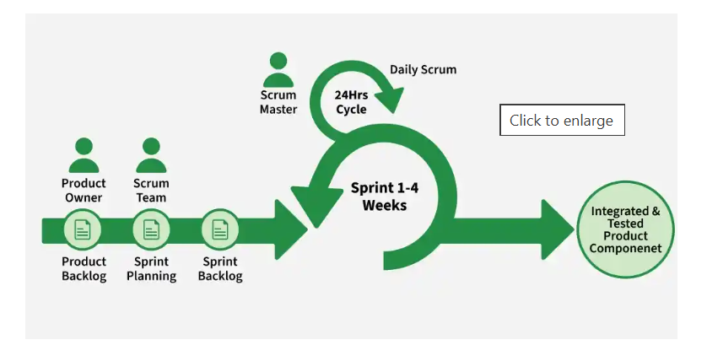
Figure 3.1: Illustration of Scrum model steps (geeksforgeeks.org, 2023).

3.3.1 Product backlog
During this phase, the proposed system requirements will be identified, prioritized and organized based on the three main stakeholders’ needs – players, coaches/scouts and administrators. Information gathered through surveys, literature review and online research will assist in understanding and addressing the main challenges such as limited player exposure and poor communication. These findings will be converted into backlog items such as player profile management, opportunity posting, video upload features and technical tasks. The Product Owner and the development team will prioritize and continuously update the backlog according to stakeholder’s feedback and changing system requirements.
Both the qualitative data - such as user preferences and system expectations and quantitative data - such as frequency of player profiles creation, video uploads and number of opportunities posted compared to applied will effectively establish a clear view on what the system does functionally and non-functionally.

3.3.2 Sprint planning and backlog
During this stage, the selected items or tasks are divided into small and manageable activities to be developed within a specific sprint cycle. Each sprint targets a specific identified module of the proposed system. For instance, Sprint one may focus on the admin module covering user management, account approvals and system monitoring. The team commits to delivering incremental value on the functional parts of the football talent identification system according to an execution plan.
Furthermore, the proposed system will implement the Object-Oriented Analysis and design (OOAD) approach, using analysis diagrams such as use case, class diagrams, Sequence diagrams, Entity -Relationship diagrams, database schemas and wireframes. The development team will use Draw.io to draw these diagrams because it displays clear visualization of system parts and is easy to use for system design. The diagrams help illustrate how the system will work, thereby guiding the development team effectively during design and implementation.

3.3.3 Sprint (Development phase)
The proposed solution is a web-based system designed to give digital access, management of data and a centralized platform to the users. From the users of the system the major inputs which are the functional and non-functional requirements are collected. In the frontend development the user interface is created like login, profile pages and dashboards. The backend implements logic and data storage, user authentication and functionalities like searching and profile management. A database for the players and scouts’ data is modelled and developed including relations. The front end and backend are then connected.
Tools like Django’s mvt framework, HTML, CSS and JavaScript will be necessary for front end development as they have flexible and user-friendly interfaces. For the backend coding, Django’s architecture will be used for coding as it aligns with object-oriented approach and is fast, scalable with built in security features. MySQL via XAMPP for data storage which gives reliable and efficient storage of structured data suitable for players and scouts data. The programming language that will be used to develop this system will be python due to its simplicity, usability and support for object-oriented programming. Visual studio code will be the preferred IDE due to its flexibility for different languages, and reliability.

3.3.4 Finished work (Testing)
To ascertain the accuracy of the system for its purpose, the functional and non-functional requirements will be assessed using iterative testing according to Agile principles. The system will undergo certain tests to check the performance, reliability and usability. If any issues are realised the debugging process will be done where identification of errors and fixing is done to improve system functionality. Some of the tests include; unit testing for the modules, integration testing for interaction between components, system testing, performance testing, user acceptance testing for user friendliness .This testing techniques are expected to be able to test the capabilities and any weaknesses of the system aspiring to address the gaps of the current unstructured football talent identification systems.

3.4 Deliverables
The proposed project produces written documents such as proposal, design documentation and test cases documentation which guides developers and help future users understand the system. It also includes system representations like design diagrams providing a clear visual structure and interactions of the system components. The working system will be developed into three main modules -such as player, admin and coach/scout module reflecting real-world entities, which makes the system easy to build, test and maintain.
The system will also define different users and roles, where players, coaches and administrators have different access levels depending on their responsibilities in the system. Moreover, the system will include security and authentication mechanisms such as login credentials, authentication and role-based access control to ensure only authorized users can access specific features of the system. Lastly, the platform will support reporting and decision-making, where data like player profiles can be processed into reports to assist coaches to view talents and make informed decisions.

Chapter 4: System Analysis and Design

4.1 Introduction
This chapter discusses the system requirements both functional and non-functional with an aim of representing clear flow of processes and system functions. It also comprises of diagrams to demonstrate the actors of the system and the functions they can perform. The functional requirements represent what processes happen within the system by the actors. The non-functional requirements represent what features help to improve, maintain and enhance the operations of the system. The design diagrams demonstrate how the system will look from an architectural view including the wireframes.

4.2 System Requirements
The Football Talent Identification and Exposure system is designed with a clear understanding of its key stakeholders and their real-world experiences. The primary users include players who are seeking exposure through opportunities to progress in their football careers and scouts who can be able to post these football opportunities to identify and expose the young talented players. The secondary stakeholders, the administrators, ensure proper verification and system control. Currently, the talent identification process is unstructured which often leads to delay and limited visibility of talent beyond local networks. As a result, players rely on informal methods such as physical trials while modern sports systems use centralized and data driven approaches highlighting a gap that this system aims to address. Ultimately, success is achieved when the system provides a reliable and transparent platform where players can create profiles to showcase their talents as scouting opportunities are easily accessible. Hence, talent identification is efficient by ensuring all the requirements are clearly defined and met.

4.2.1 Functional Requirements
This section presents the functional requirements of the Football Talent Identification and Exposure System uniquely describes each stakeholder roles and how the system responds to inputs, processes data and generate outputs to the stakeholders’ requests as per the input.
The player is able to register and log into the system by providing valid credentials, where the system validates the input, creates an account and store player details securely. The player is only able to create and update a personal profile, which is saved in the system and made available for scouting visibility. The player can upload performance videos and match highlights, which is saved in the system. The system allows the player to view available trials or tournaments, where opportunities are retrieved from stored scout postings. The player is also able to apply the viewed trials or tournaments, where the system validates the application, stores the submission record and generate an application confirmation. The system also can allow the player logout requests by ending the session and storing the logout activity logs.
The scout can register and log into the system, where the system validates the submitted credentials and stores the scout details in the database. The scout goes another step to submit verification documents, which the system validates and stores for administrative review. The system restricts any scout from posting football opportunities until verification documents are approved by the administrator. Once approval is granted, the system grants posting privileges which allows the approved scout to create and post trials or tournaments hence are published and made available for players to view and apply for. The scout can view player profiles and uploaded videos retrieved from system database. Lastly, the scout can log out, where the session terminates and logout records are stored.
The administrator can log into the system with correct credentials, where login activity is recorded. The admin can retrieve and review verification documents submitted by scouts, where the system displays the stored records for decision-making. The admin goes another step to approve or reject scout verification requests, where approved scouts are updated with posting privileges while rejected submissions are flagged with appropriate system notifications. The admin can also manage player and scout accounts by either creating accounts or updating accounts or deleting accounts with all changes stored in the system database. In addition, the admin monitors the system data and generate performance reports to support system evaluation. Finally, the admin can log out where the system ends the session and stores logout records.

4.2.2 Non-Functional Requirements
To enhance the overall quality of the system and improve user experience, the proposed Football Talent Identification and Exposure System incorporate several features that support key non-functional requirements such as performance, speed, reliability, security, maintainability, usability, and scalability. Performance is enhanced through Django's Object Relational Mapper (ORM), which enables efficient retrieval and management of data from the database. Django also supports caching mechanisms that reduce database strain by storing frequently accessed information. Speed is improved through Django's Model-View-Template (MVT) architecture, which facilitates efficient processing of user requests and generation of responses. Security is achieved through features such as password hashing, user authentication, role-based access control, and Django's built-in protection against common web vulnerabilities including Cross-Site Scripting (XSS) and Cross-Site Request Forgery (CSRF).
Reliability is enhanced through Django's robust framework structure, automatic form validation, and error-handling mechanisms, which help ensure consistent system operation and data integrity. Usability is supported through friendly user interfaces, simple registration and profile creation forms, automated form validation, and search functionalities that enable users to interact with the system easily. Maintainability is achieved through Django's modular architecture, reusable applications, and built-in administration panel, allowing developers to update and manage the system efficiently. Furthermore, the system is scalable and can accommodate future growth in the number of users, player profiles, and opportunities without significant architectural changes. These features collectively contribute to a secure, efficient, reliable, and user-friendly platform that supports effective football talent identification and exposure.

4.3 Analysis and Design Diagrams
Following the OOAD approach, the following diagrams were drawn:

4.3.1 Use case Diagram
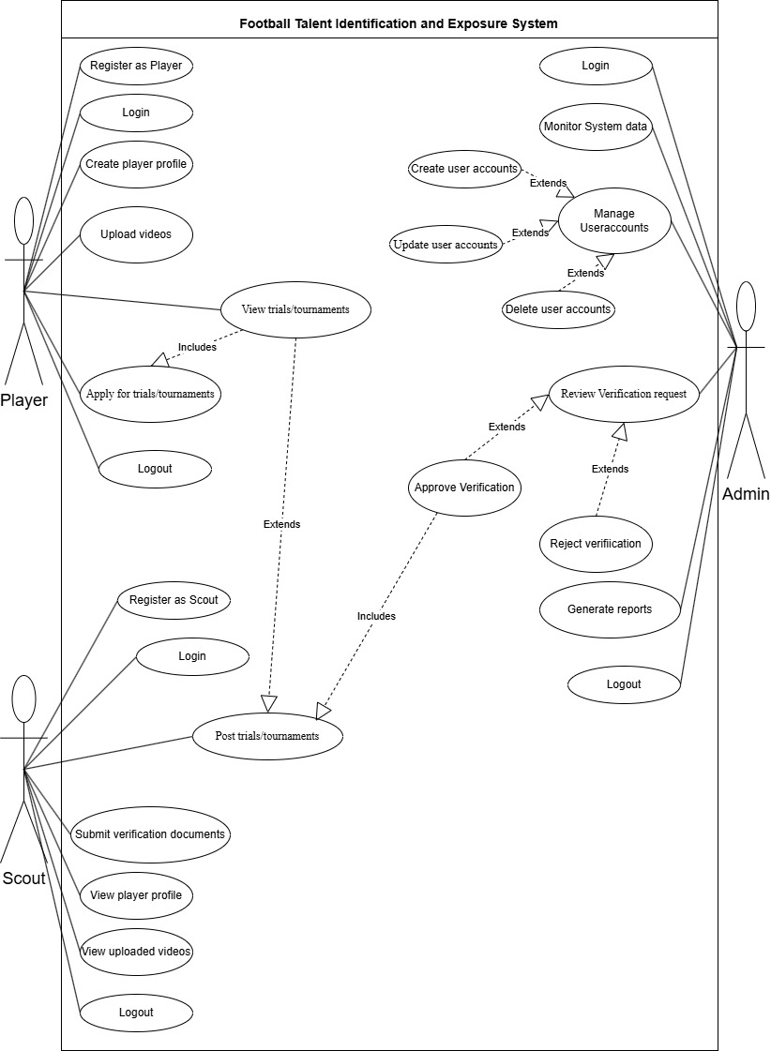
Figure 4. 1:Use Case Diagram

4.3.2 Class Diagram
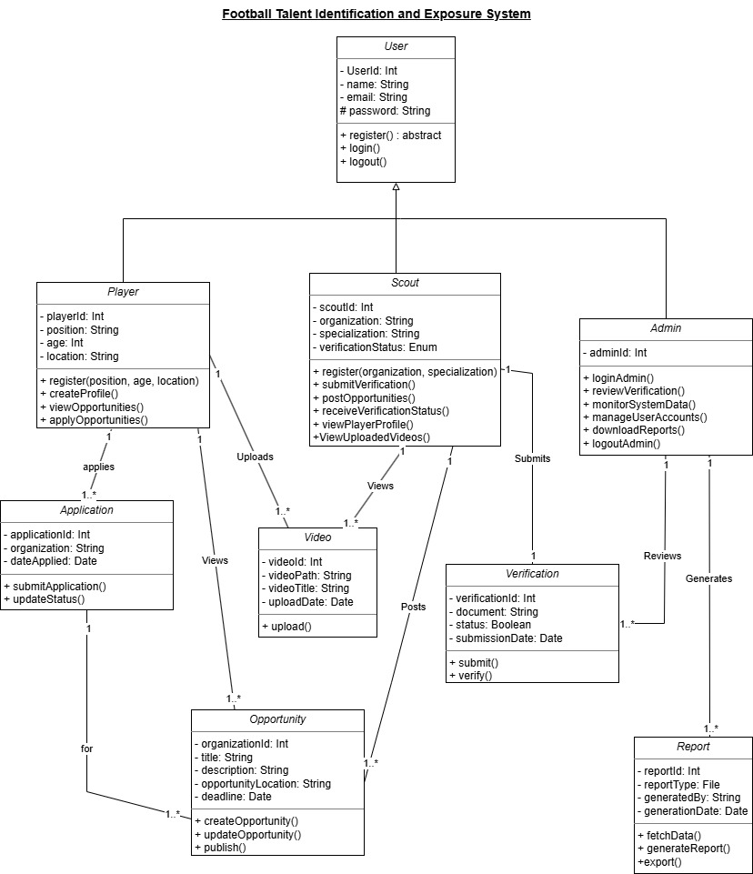
Figure 4. 2:Class Diagram

4.3.3 Sequence Diagram
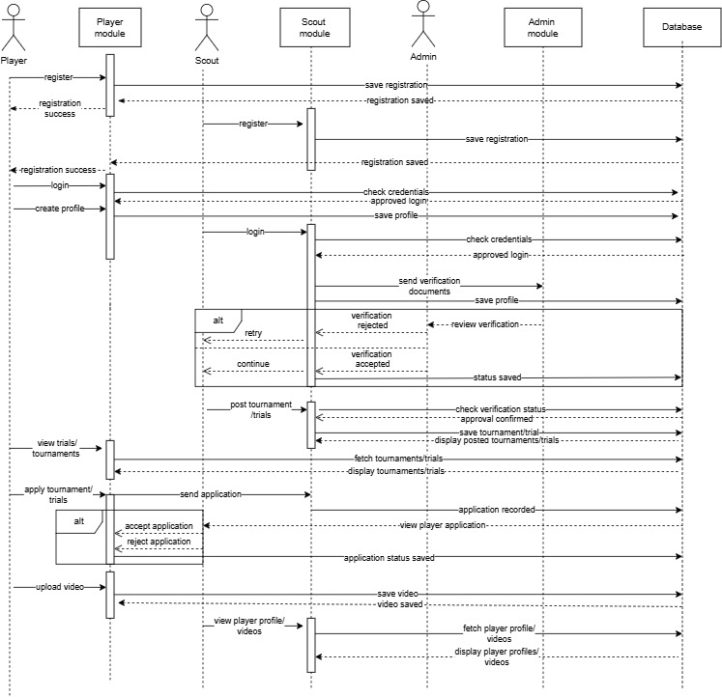
Figure 4. 3:Sequence Diagram

4.3.4 ERD Diagram
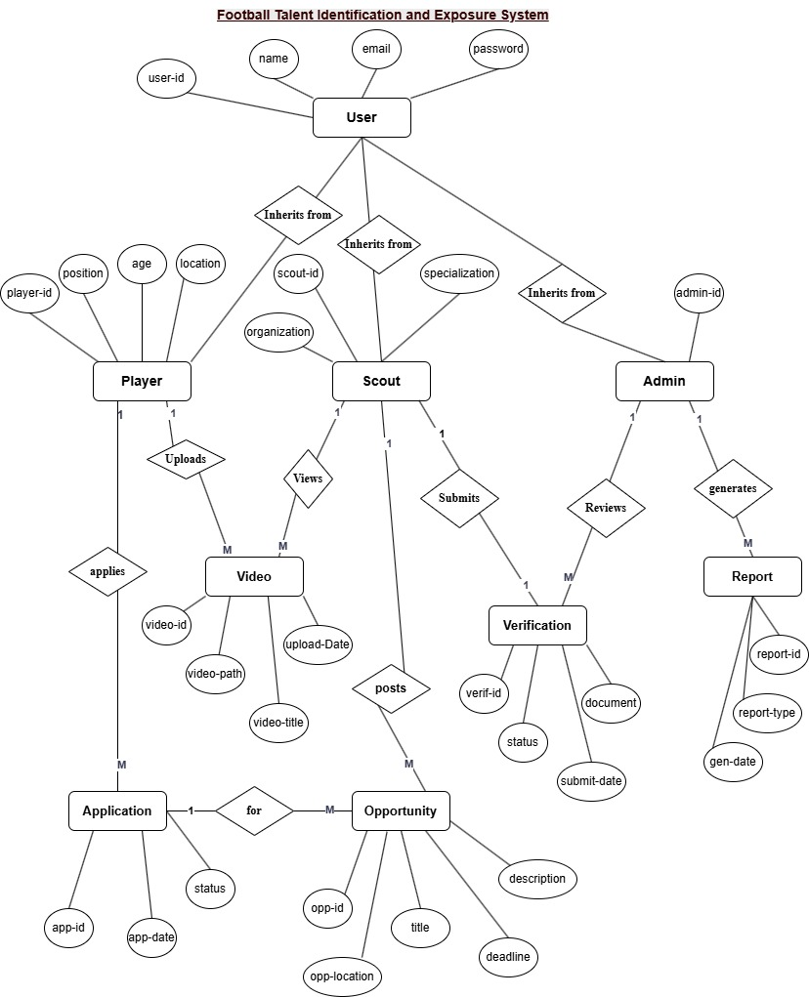
Figure 4. 4: ERD

4.3.5 Database Schema
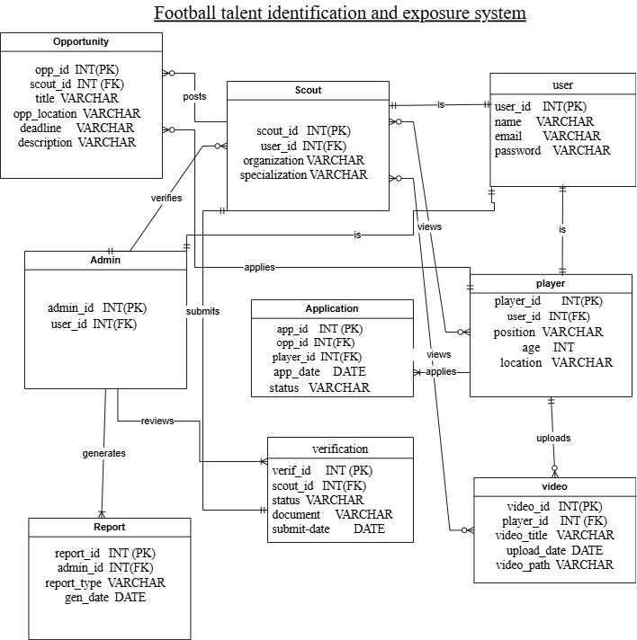
Figure 4. 5:Database Schema

4.3.6 Wireframes
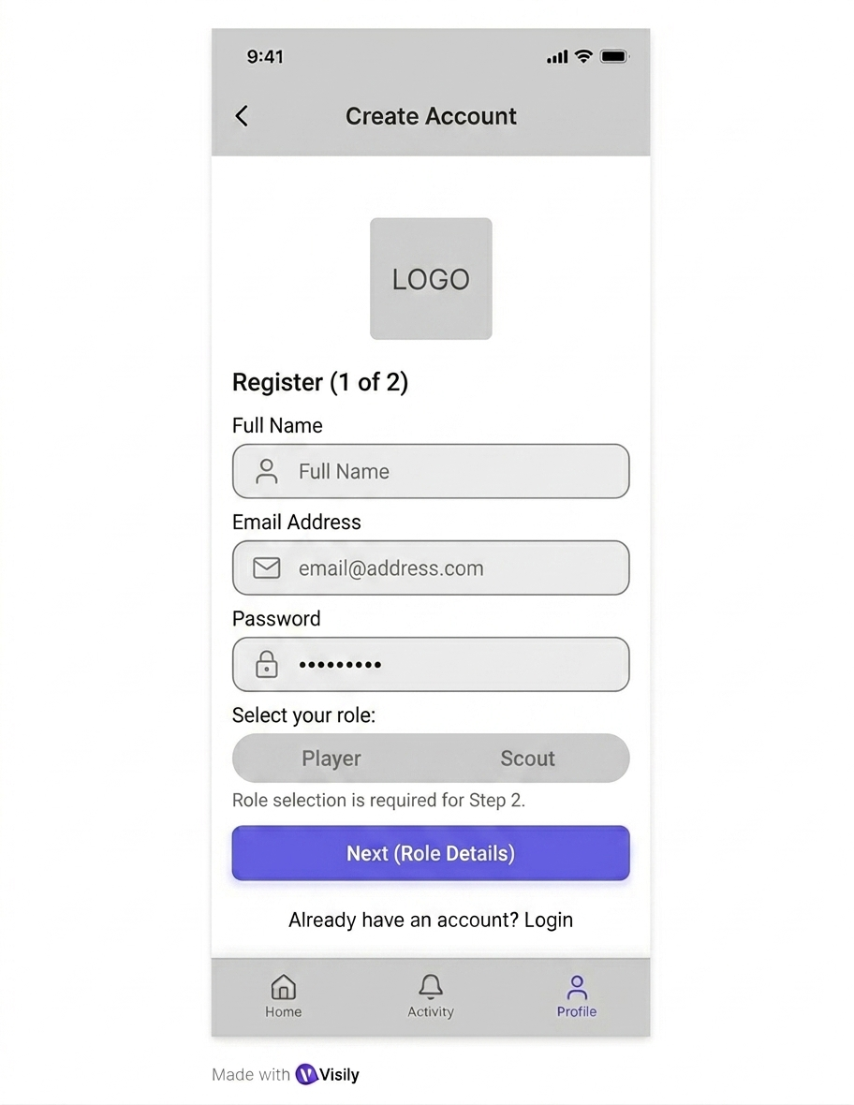


Figure 4. 6:Wireframes

References
Alemmebrat, K. (2022). TALENT IDENTIFICATION PRACTICES AND CHALLENGES OF COACHES: IN IDENTIFYING TALENTED YOUNG FOOTBALL PLAYERS. International Journal of Sports Sciences & Fitness, 2022, Vol 12, Issue 1, p1.
Armstrong. (2022). Share of foreign players in the English Premier League. From Statista: https://www.statista.com
Baker, K. t. (2020). Challenges and [Possible] Solutions to Optimizing Talent Identification and Development in Sport. Challenges and [Possible] Solutions to Optimizing Talent Identification and Development in Sport.
David Graff, B. K. (2026). Hudl. doi:https://www.hudl.com/en_gb/
Del Fava, E. A. (2021). Social contact patterns and informal community engagement in Kenya. BMC Public Health, 356. From https://bmcpublichealth.biomedcentral.com/articles/10.1186/s12889-021-10355-4
Dimitris Kothroulas, E. C. (2025). THE TRANSFORMATIVE ROLE OF FOOTBALL ACADEMIES IN THE MODERN FOOTBALL ECOSYSTEM. THE TRANSFORMATIVE ROLE OF FOOTBALL ACADEMIES IN THE MODERN FOOTBALL ECOSYSTEM, 12. doi: http://dx.doi.org/10.46827/ejpe.v12i7.6065
Emmanuel. (2026). Inequality in football scouting systems in Africa. African Journal of Sports Development, 55-70.
Fabian Hammess, A. H. (2022). Artificial Intelligence in Elite Sports—A Narrative Review of Success Stories and Challenges. Artificial Intelligence in Elite Sports—A Narrative Review of Success Stories and Challenges, 4. doi:https://doi.org/10.3389/fspor.2022.861466
FIFA. (2023, March 17). FIFA Talent Development Guidelines. From FIFA: https://inside.fifa.com/en/talent-development
FIFA. (n.d.). fifa.com/technical/talent-development. From fifa.com.
FIFA Talent Development Scheme. (2022). From FIFA: https://www.fifa.com/technical/talent-development
FKF calls for data-driven scouting as nationwide scouting reforms get underway. (2026, 02 27). Nairobi, Nairobi, Kenya. From https://www.citizen.digital/sports/fkf-calls-for-data-driven-scouting-as-nationwide-scouting-reforms-get-underway-n378201
geeksforgeeks.org. (2023, April 23). Scrum in Software Development. From geeksforgeeks: https://www.geeksforgeeks.org/software-engineering/scrum-software-development/
John Muchira, R. J. (2023). Implementing Competency Based Curriculum (CBC) in Kenya: Challenges and Lessons from South Korea and USA. Implementing Competency Based Curriculum (CBC) in Kenya: Challenges and Lessons from South Korea and USA, 12(3). From https://ccsenet.org/journal/index.php/jel/article/view/0/48691
Kitamba. (2025). FKF launches nationwide U14 and U15 scouting programs. From Capital Sports: https://www.capitalfm.co.ke/sports/
McCalman, e. a. (2022). Skill Acquisition in Sport: Research, Theory and Practice. London: Routledge. From https://doi.org/10.4324/9781003052232
Mohamed. (2025). Football development structures in Kenya. Nairobi: Citizen Digital. From https://www.citizen.digital/sports/fkf-calls-for-data-driven-scouting
Mwangi, M. T. (2023). Talent Management, Participation in Sports & Phsical education. From http://dx.doi.org/10.6007/IJARPED/v12-i1/13015
Nashipae. (2022). Implementation of competency-based curriculum in Kenya. African Journal of Education and Practice. African Journal of Education and Practice, 78-91. From https://www.ajol.info/index.php/ajep/article/view/
Nashipae, T. (2022, 12 Friday 30th). CBC is an effective bottom-up approach to sports development in Kenya. Nairobi, Nairobi, Kenya. From https://www.mozzartsport.co.ke/other%20sports/news/nashipae-cbc-is-an-effective-bottom-up-approach-to-sports-development-in-kenya/25138?
Paul R. Ford, J. L. (2023). A survey of talent identification and development processes in the youth academies of professional soccer clubs from around the world. 10.
Prisca Amajuoyi, L. B. (2024). Agile methodologies: Adapting product management to rapidly changing market conditions. Agile methodologies: Adapting product management to rapidly changing market conditions. doi:10.30574/gscarr.2024.19.2.0181
Rahim, A. (2025). A Systems-Based Approach to Talent Identification in Youth Football. A Systems-Based Approach to Talent Identification in Youth Football, 39. From https://www.diva-portal.org/smash/record.jsf?pid=diva2%3A1977159&dswid=-6654
Ribeiro et al., 2. (2025). International Journal of Sports Science and Coaching, 2709-2728. From https://doi.org/10.1177/17479541251365776
Rohit, S. M. (2025). AI in Talent Scouting and Player Development: Role of AI and Machine Learning in Identifying and Nurturing Talent in Sports Organizations. AI in Talent Scouting and Player Development: Role of AI and Machine Learning in Identifying and Nurturing Talent in Sports Organizations, 24.
Sam Barraclough, K. T. (2022). Methodological Approaches to Talent Identification in Team Sports: A Narrative Review. Sports, 10((6)Talent Identification and Development in Youth Sports). doi: https://doi.org/10.3390/sports10060081
Sanja Maravić Čisar, R. P. (2025). The Impact of Scrum Methodology on Student Motivation and Problem-Solving Skills. The Impact of Scrum Methodology on Student Motivation and Problem-Solving Skills. doi:10.7906/indecs.23.2.8
Sérgio Ribeiro, F. C.-V. (2025). What does research tell us about scouting in football? 20(6). From https://journals.sagepub.com/doi/epub/10.1177/17479541251365776
Streamline. (2025). FKF Urges Stronger Grassroots Football Foundation in Kenya. Kenya: Steamline. From https://streamlinefeed.co.ke/news/fkf-urges-stronger-grassroots-football-foundation-in-kenya
Waffo, B. T. (2025). Barriers to football talent development in Africa. African Sports Studies, 34-49. From https://www.fifa.com/technical/talent-development
Zhang, X. (2022, January 04). Analysis and Design of Physical Education Option Course Selection Subsystem Based on UML. Analysis and Design of Physical Education Option Course Selection Subsystem Based on UML, 397 -402. doi:https://doi.org/10.1007/978-981-16-4258-6_49

